KE30 -

Functionality
In this transaction you can analyze your profitability data in drilldown reporting. Execute a report that has been defined in accordance with your requirements.

Scenario
You are supposed to prepare profitability report for Company Code 5200 for the whole year 2002, according to profit center hierarchy. After execution of the report a currency of the report must change from USD to SAR.

Prerequisites
None.

Menu Path | SAP menu → Accounting → Controlling → Profitability Analysis → Information System → KE30 - Execute Report
Transaction Code | KE30

1. Double Click on KE30 - Execute Report.

Run Profitability Report: Initial Screen

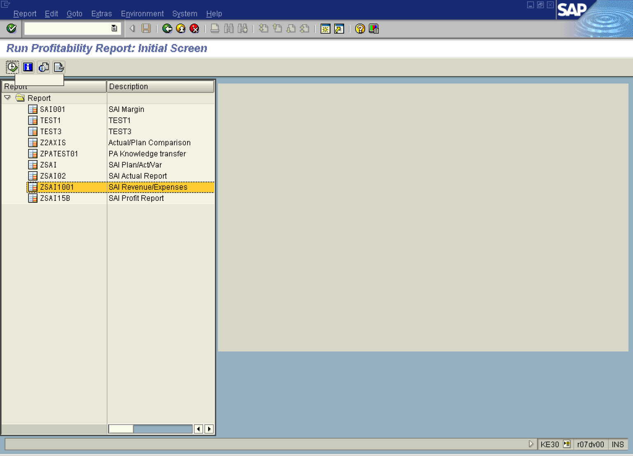

2. Select the ZSAI1001 tree view node – choose report appropriate for your requirements.
3. Click the Execute button.
Selection: SAI Revenue/Expenses

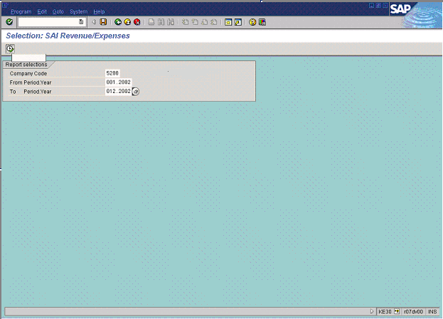

4. Update the following fields:

Field Name | Field Description | Values
Company Code | Organizational unit in FI that represents business entity. | Example: 5200
From Period.Year | From Period.Year, 0MM.YYYY | Example: 001.2002
To Period.Year | To Period.Year, 0MM.YYYY | Example: 012.2002

5. Click the Execute button.
Execute Drilldown Report "SAI Revenue/Expenses": Drilldown List

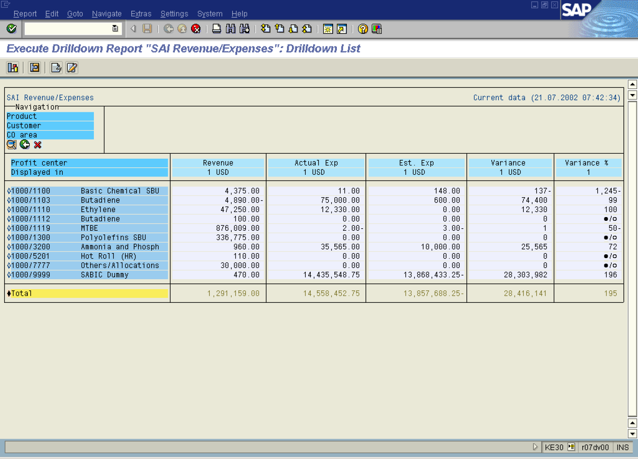

6. Click the Product field in the Navigation Section to move this characteristic to the right section and break the data according to the Product.

Execute Drilldown Report "SAI Revenue/Expenses": Drilldown List

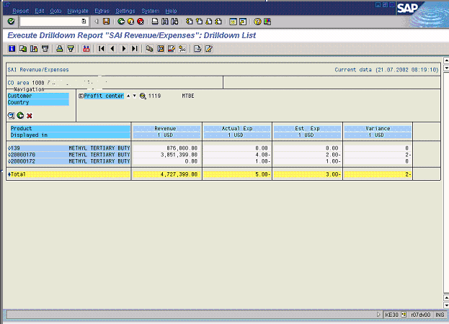

7. Click the Customer field in the Navigation Section to move this characteristic to the right section and brake the data according to the Customer.

Execute Drilldown Report "SAI Revenue/Expenses": Drilldown List

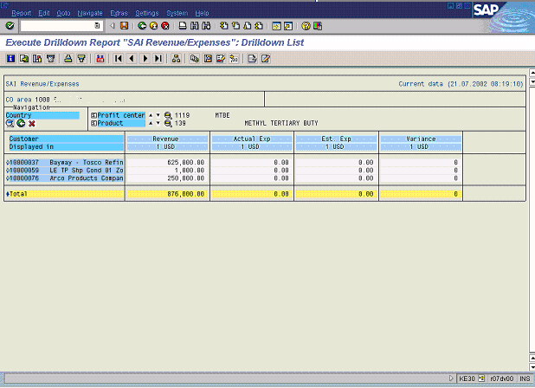

8. Click the button to move back the first characteristic into Navigation Section.
9. Click the button to move back the second characteristic into Navigation Section.

Execute Drilldown Report "SAI Revenue/Expenses": Drilldown List

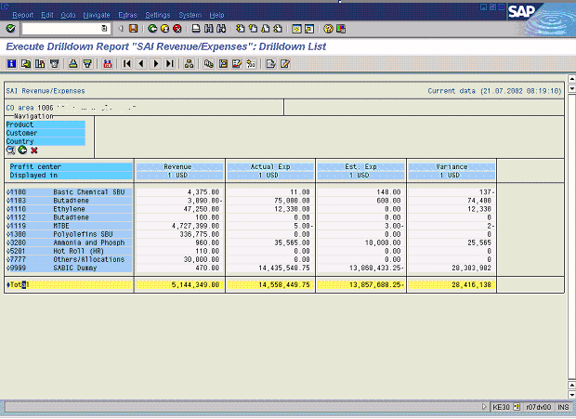

10. Click the Total line to highlight it.

11. Click the Details button to change the layout of the report. Key figures from columns are moved into lines.

Execute Drilldown Report "SAI Revenue/Expenses": Drilldown List

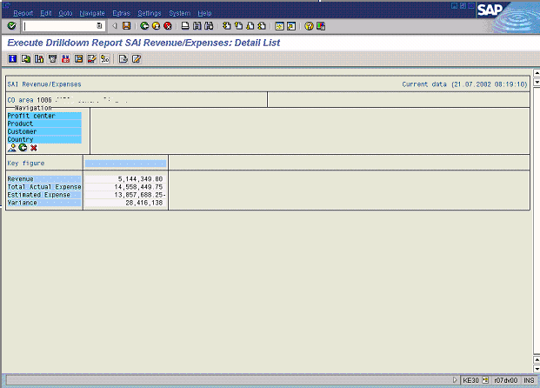

12. Click the Customer field in the Navigation Section to move this characteristic to the right section and brake the data according to the Customer.

Execute Drilldown Report "SAI Revenue/Expenses": Drilldown List

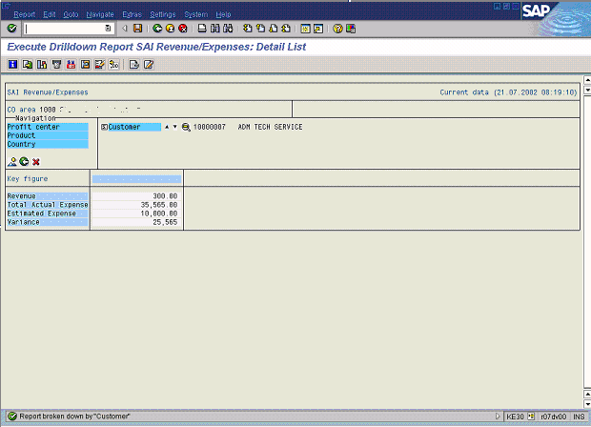

13. Click the Customer button to switch between different Customers.

Execute Drilldown Report "SAI Revenue/Expenses": Drilldown List

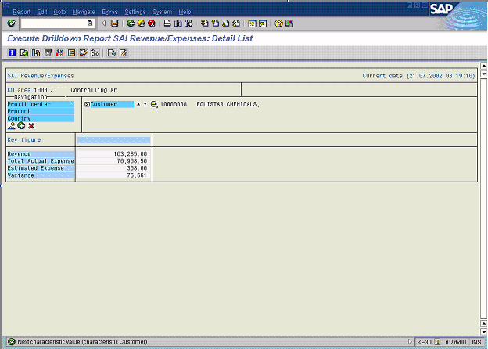

14. Click the Product field in the Navigation Section to move this characteristic to the right section and brake the data according to the Product.

Execute Drilldown Report "SAI Revenue/Expenses": Drilldown List

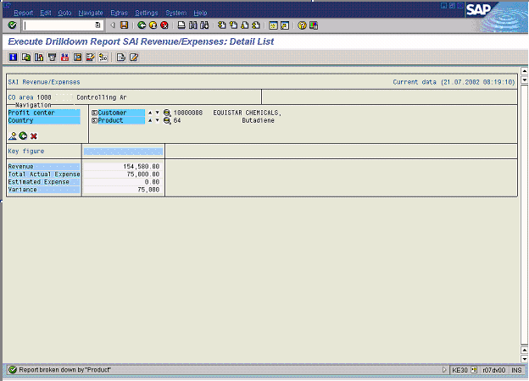

15. Click the Product button to switch between different Products.

Execute Drilldown Report "SAI Revenue/Expenses": Drilldown List

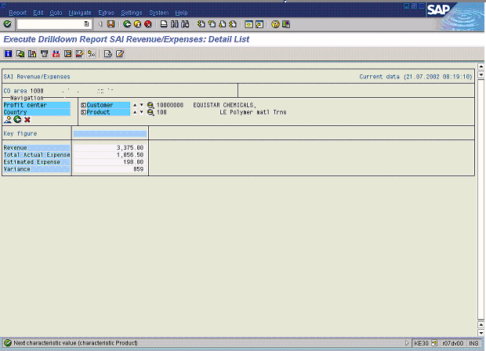

16. Click the Product button to switch between different Products.

17. Click the button.

Execute Drilldown Report "SAI Revenue/Expenses": Drilldown List

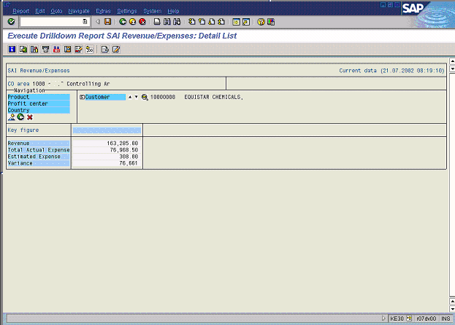

18. Click the Back button.

Execute Drilldown Report "SAI Revenue/Expenses": Drilldown List

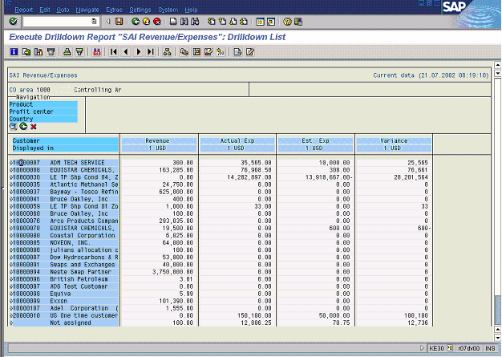

19. From the SAP main menu, use the following menu path: NavigateSwitch drilldown....

Switch Drilldown Characteristic

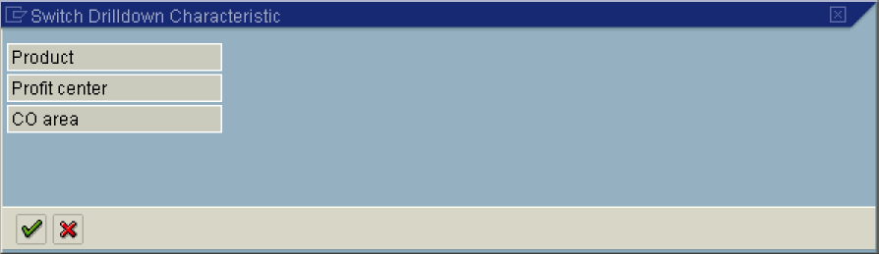

Execute Drilldown Report "SAI Revenue/Expenses": Drilldown List

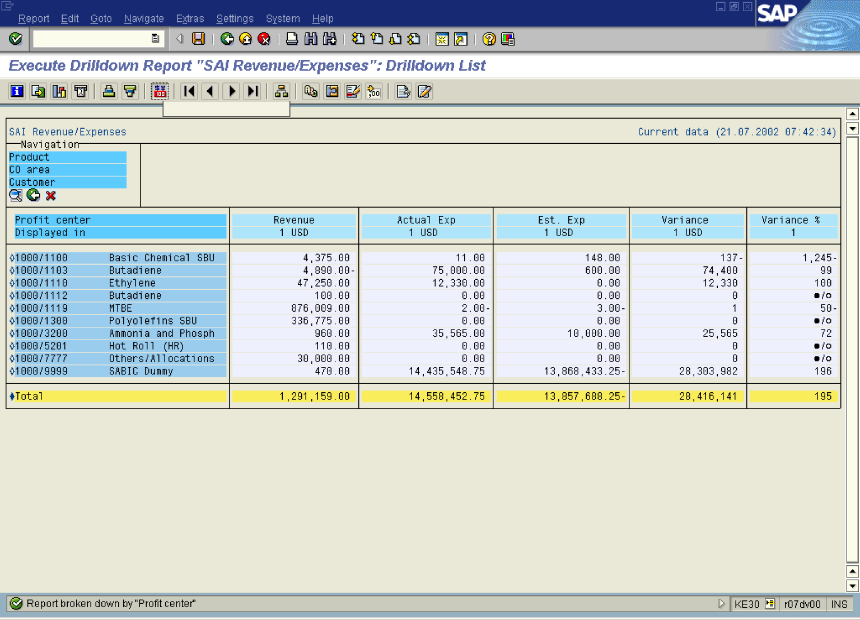

20. Click Button .

Currency Translation: All Columns

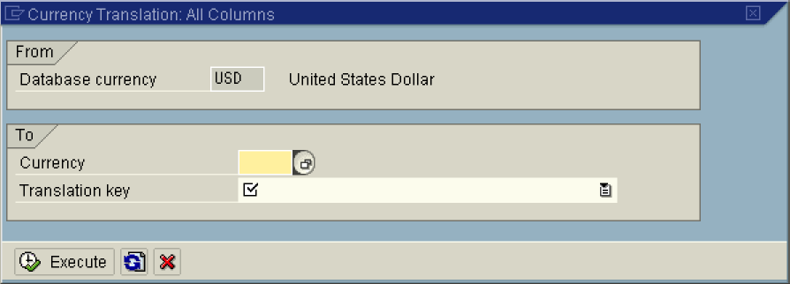

21. Click Currency Button .

To-currency (1) 185 Entries found

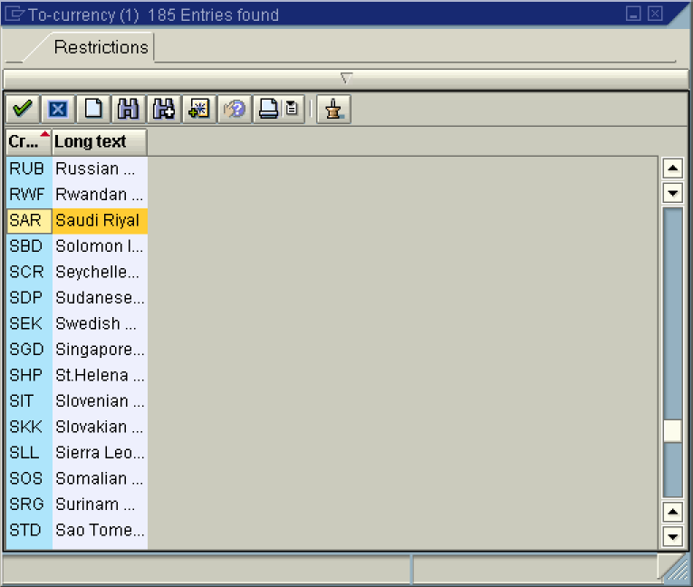

22. Select the SAR - Saudi Riyal in list box.

Currency Translation: All Columns

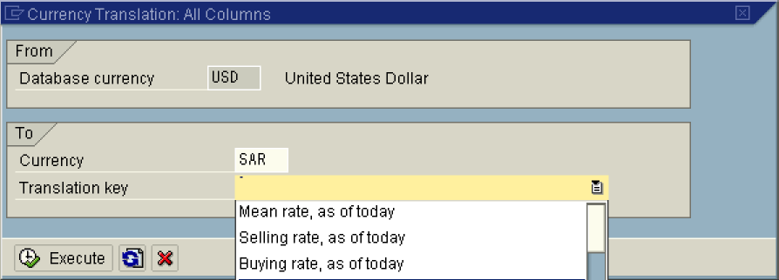

23. Click Translation key Button .
24. Select Default for drilldown reporting in list box.
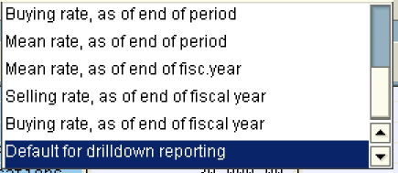

Currency Translation: All Columns

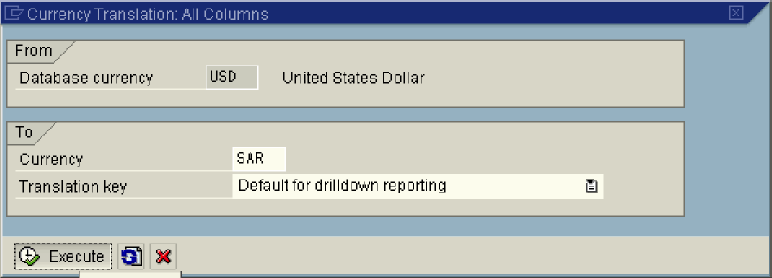

25. Click the Execute button.

Execute Drilldown Report "SAI Revenue/Expenses": Drilldown List

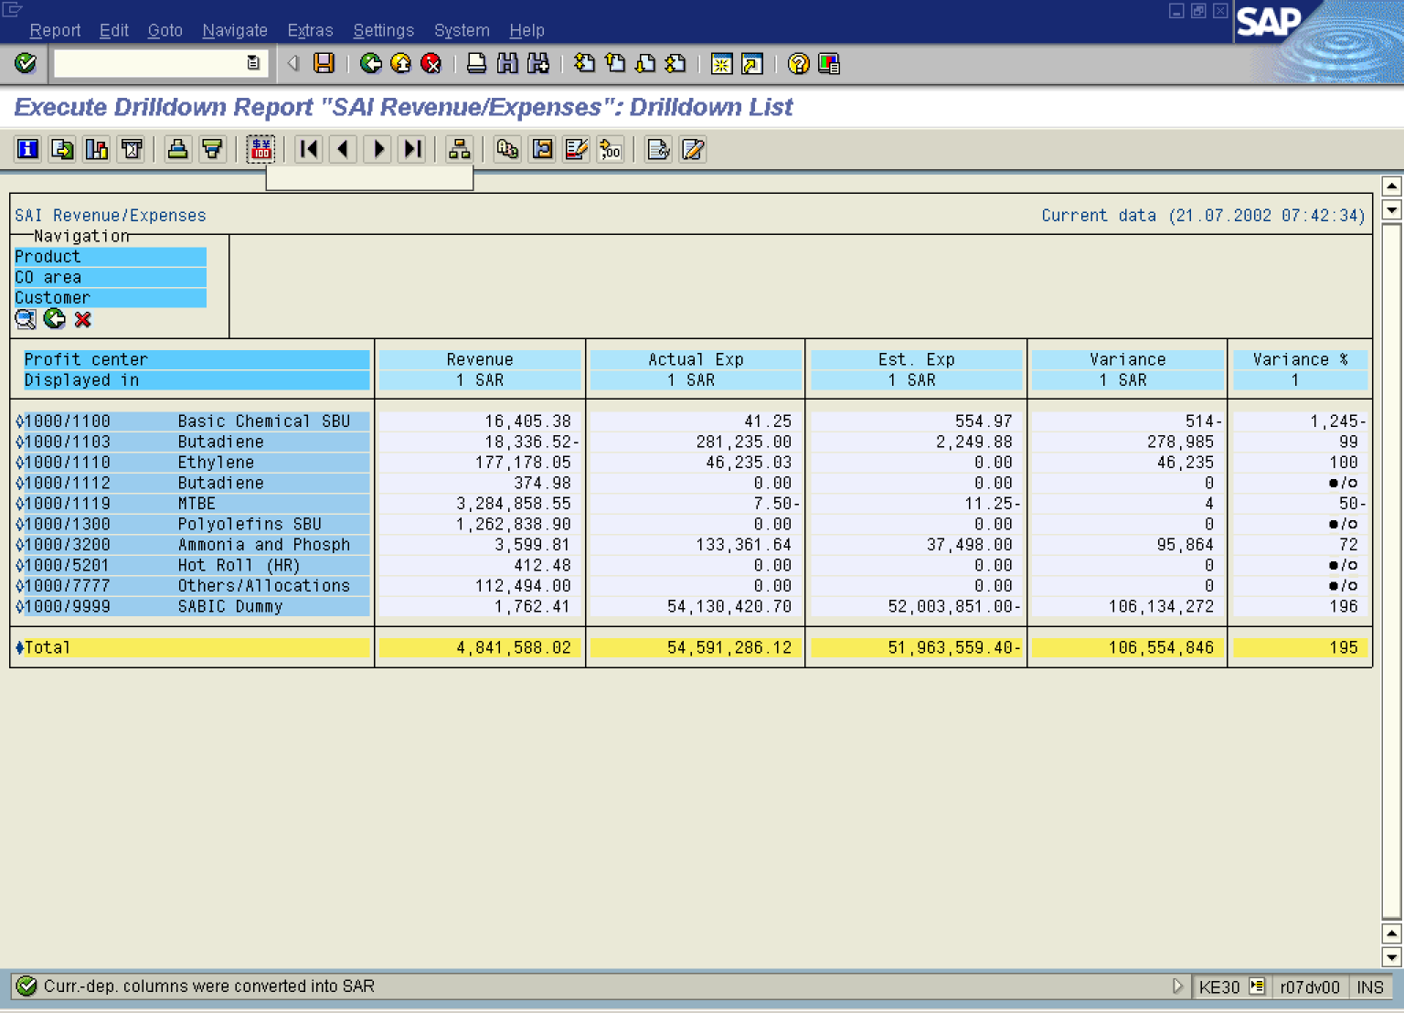

26. Click the Back button.

Exit Report

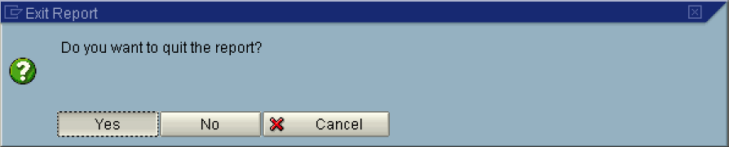

27. Click Yes Button .

